Title: Outcomes of THA/TKA in Patients with Osteogenesis Imperfecta: A Systematic Review
Declarations
No funding was received for conducting this study.
This study did not require ethical approval or informed consent as it is a systematic review based entirely on previously published literature. No primary data collection was conducted, and no identifiable patient information was accessed or utilized. All data were sourced from publicly available, peer-reviewed publications. IRB review was not required.

Abstract
Purpose
Patients with osteogenesis imperfecta (OI) have a significantly higher risk of developing osteoarthritis, resulting in an increasing need for hip and knee arthroplasty. To date, the literature consists primarily of isolated case reports and case series. Thus, the aim of this study is to synthesize existing literature to characterize outcomes of THA and TKA in patients with OI.
Methods
Studies assessing the outcomes of THA and TKA in patients with OI published before September 2025 were queried using Embase, MEDLINE, Cochrane Library and Web of Science. A total of 19 studies met inclusion criteria and were included in this review.
Results
Among patients with OI, 31 underwent THA (mean age 41.7 years; 18F/13M) and 20 underwent TKA (mean age 52.7 years; 13F/7M). Pain resolved or partially improved in 7 THA patients, with revision required in 9/31 (29%) due to infection, loosening, or prosthetic protrusion; fixation was cemented in 20 and uncemented in 7. TKA demonstrated substantial functional improvement, with Knee Society Scores rising from 16–42 to 68–90 and functional scores from 40–50 to 80–100, though revision was required in 8/18 (44%, 90% reporting); all TKAs used cemented fixation.
Conclusions
THA and TKA can offer symptomatic and functional benefits in patients with OI, though reported revision rates remain high due to implant loosening and malunion. TKA appears to yield greater pain relief than THA, though functional gains remain modest for both. Evidence is limited to case reports, and future studies leveraging large national databases may better characterize long-term outcomes.
Keywords: Total Hip Arthroplasty, Total Knee Arthroplasty, Total Hip Replacement, Total Knee Replacement, Osteogenesis Imperfecta, Systematic Review

Introduction
Osteogenesis imperfecta (OI) is a genetically heterogeneous group of connective tissue disorders characterized primarily by bone fragility, susceptibility to fractures from minimal trauma, and low bone mineral density or osteopenia [1, 2]. The classic forms of OI are most commonly caused by autosomal dominant mutations in the COL1A1 and COL1A2 genes, which encode the α1(I) and α2(I) chains of type I collagen, the major structural protein in bone and other connective tissues. These mutations lead to either quantitative or qualitative defects in type I collagen, resulting in impaired bone strength and structure [3-6]. OI has a substantial negative impact on quality of life, primarily due to physical limitations, chronic pain, fatigue, and restrictions in daily activities. Physical domains of quality of life are consistently lower in both children and adults with OI compared to the general population, with greater disease severity and higher fracture frequency associated with worse physical functioning and increased pain and fatigue [7-15]. Limitations affect mobility, activities of leisure, employment opportunities, and independence. Chronic pain is frequent and interferes with daily activities, regardless of OI severity [9, 14].
Patients with OI develop osteoarthritis and functional impairment due to chronic bone fragility, deformities, and previous fractures [16-18]. Patients with osteogenesis imperfecta have a markedly increased risk of osteoarthritis compared with the general population, with a sub-hazard ratio of 2.20 and an earlier age of disease onset [19]. Management of this patient population often involves a multidisciplinary approach focused on optimizing surgical outcomes and quality of life through physical therapy, pain management, medical optimization of bone health, and surgical interventions such as arthroplasty, intramedullary rodding, or osteotomies for deformity correction [1, 20, 21]. In cases of advanced degenerative joint disease, total hip arthroplasty or total knee arthroplasty become necessary [1]. However, these patients present unique anatomical and biomechanical challenges, making arthroplasty a technically complex and higher-risk procedure [16-18, 22-35]. TKA and THA in OI require meticulous preoperative planning due to abnormal bone anatomy, deformities, and poor bone quality, often necessitating custom implants or cemented fixation [17, 26, 30, 35]. Anatomic deformities such as bowing, malunion, coxa vara, and acetabular protrusion further complicate implant positioning and may necessitate the use of custom or cemented implants to accommodate abnormal bone geometry and ensure adequate fixation [16, 17, 35, 36]. Additionally, previous hardware from childhood surgeries can interfere with surgical planning and implant placement, requiring careful preoperative assessment and sometimes removal or adaptation of existing devices [35-37].
Given the complex nature of these procedures and the rarity of OI cases, it is important to evaluate the existing evidence on patient outcomes following total hip and knee arthroplasty. To date, the literature consists primarily of isolated case reports and case series, with no systematic reviews. Thus, the aim of this study is to present and synthesize the existing literature to characterize overall outcomes of THA and TKA in patients with osteogenesis imperfecta.

Methods
A comprehensive systematic literature search was conducted on September 25, 2025 to investigate THA and TKA procedure outcomes in patients with OI. This systematic review was conducted in accordance with the Preferred Reporting Items for Systematic Reviews and Meta-Analyses (PRISMA) guidelines. The protocol was prospectively registered with PROSPERO (ID: CRD1147070).
Research librarian, J.C., designed the search strategy, utilizing a combination of Medical Subject Headings (MeSH) terms and free-text keywords related to joint arthroplasty and osteogenesis imperfecta. Discrete terms and database specific search strategies are displayed in Table 1.
Complete search strategies for each database are provided in the Supplementary Materials.
Table 1. Discrete terms and database-specific search strategies used to identify papers.
Search Category | Search Terms / Strategy
Arthroplasty Terms | "Arthroplasty, Replacement, Hip," "Arthroplasty, Replacement, Knee," "Hip Prosthesis," "Knee Prosthesis," "Joint Prosthesis," and variations of hip/knee replacement, arthroplasty, implant, and prosthesis (using proximity operators of within 3 words)
Osteogenesis Imperfecta | "Osteogenesis Imperfecta," "Lobstein's Disease," "Lobstein Disease," "Fragilitas Ossium," "Brittle Bone Disease," and "Vrolik Disease"
Embase | Combined exploded MeSH headings with title/abstract/keyword searches using proximity operators (adj3)
MEDLINE (PubMed) | Utilized MeSH terms with Title/Abstract searches using proximity operators (~3)
Cochrane Library | Employed MeSH headings with NEAR/3 proximity searches
Web of Science | Used topic searches with NEAR/3 proximity operators for all search terms

Screening and Study Inclusion/Exclusion Criteria
Studies were included if they met the following criteria. The study population consisted of patients diagnosed with osteogenesis imperfecta. Eligible interventions included total hip arthroplasty or total knee arthroplasty. Acceptable study designs comprised of randomized controlled trials, prospective cohort studies, retrospective cohort studies, and case studies with limited confounding factors. Only studies published in English were considered. Additionally, studies were required to report measurable clinical outcomes with documented follow-up.
Studies were excluded at the title and abstract screening stage if patients did not have osteogenesis imperfecta, did not receive THA or TKA procedures, or if papers were letters to the editor, narrative reviews, or conference abstracts without full-text data, not published in English, or animal or cadaveric studies.
Following full-text review, additional studies were excluded if they: did not specifically address osteogenesis imperfecta, presented unclear outcomes or lacked adequate follow-up data, or were case reports with significant confounding medical conditions that precluded clear interpretation of arthroplasty outcomes in the context of osteogenesis imperfecta.
Extracted data included study characteristics such as author, publication year, study design, and sample size; patient demographic information including age and sex; surgical details specifying the type of procedure performed, either total hip arthroplasty or total knee arthroplasty; clinical outcomes including intraoperative and postoperative complications, revision rates, functional outcome scores, patient-reported outcomes, and implant survival; and follow-up information including the duration of follow-up and loss to follow-up.
The methodological quality of included studies was independently assessed by two reviewers (L.S. and A.Y.H.) using the Joanna Briggs Institute (JBI) Critical Appraisal Tools. JBI Critical Appraisal Checklist for Case Series was employed. Each included study was evaluated against the relevant checklist criteria, with responses recorded as "Yes," "No," "Unclear," or "Not Applicable" for each item. Disagreements in quality assessment were resolved through consensus discussion between the two reviewers.
Due to the anticipated heterogeneity in study designs, patient populations, and outcome measures, a narrative synthesis approach was planned. Quantitative synthesis through meta-analysis would be performed if sufficient homogeneity existed among studies in terms of patient characteristics, interventions, and outcomes.
All reported outcomes were of interest for this study.

Results
Study Selection
The initial database searches yielded 151 records. Following removal of 37 duplicate records, 114 unique studies underwent title and abstract screening. A total of 19 studies were included for this systematic review (Figure 1) [16-18, 22-29, 31-34, 38-41]. The average age of OI patients undergoing THA was 41.73 years, and the average age of patients undergoing TKA is 52.7 years.
Figure 1. PRISMA flowchart outlining inclusion/exclusion of studies through Covidence. 19 studies were included following full text review.
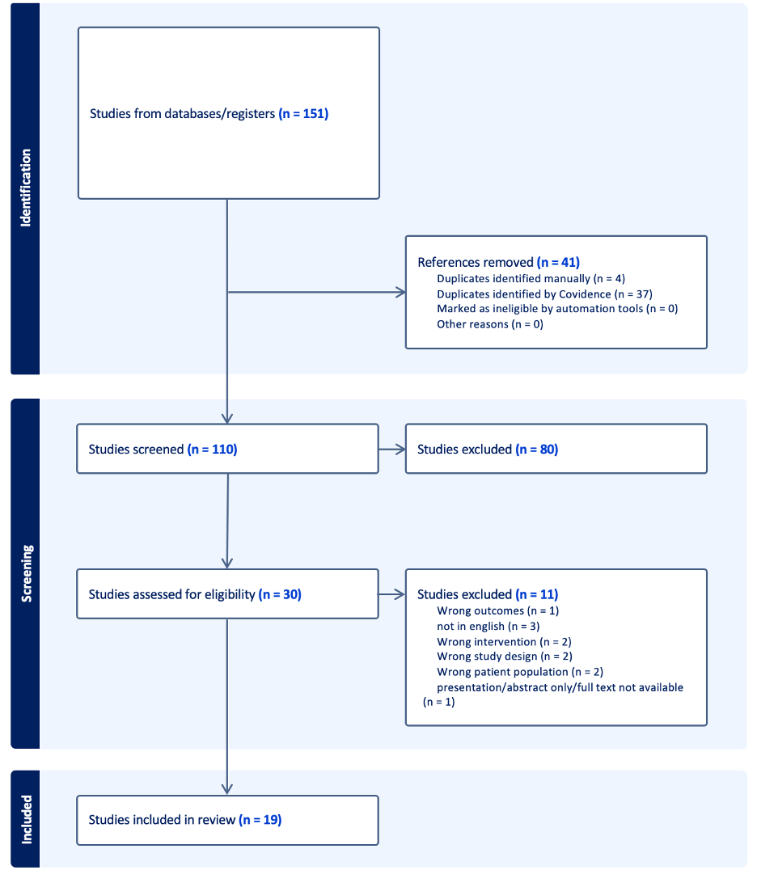
A summary of the data extracted from the 19 studies included in this review is presented in Tables 2-5 [16-18, 22-29, 31-34, 38-41]. Aggregation of patient reported pain and independent ambulation was not feasible due to heterogeneity in follow-up duration and outcome reporting.
THA Outcomes
There were a total of 59 patients who underwent THA, but only 31 patients (18 females, 13 males) were included for this review since the remaining 28 were diagnosed with a different skeletal dysplasia (Tables 2 & 3). The mean follow-up time across THA studies was 3.62 years [16, 22, 23, 25, 27, 28, 31-33, 38, 39].
Table 2 summarizes reported pain outcomes, independent ambulation, and objective postoperative measures across included studies. Ajlouni et al. described a single patient who experienced recurrence of pain at 6-month follow-up, although revision surgery was not required. Krishnan et al. reported outcomes for six patients with osteogenesis imperfecta undergoing THA; pain resolution was achieved in one patient, while five required revision surgery due to postoperative infection, loosening, or prosthetic protrusion. Liporace et al. reported complete pain resolution at 10 months postoperatively in one patient without need for revision. Papagelopoulos et al. observed partial pain relief in all four patients undergoing THA, with one requiring revision surgery. In contrast, Bizot et al., Charen et al., and Nishida et al. reported suboptimal postoperative outcomes, with all patients requiring revision procedures.
Long term outcomes following THA included revision surgeries. Data extracted from these studies are depicted in Table 3. Among studies reporting fixation method (87% reporting), 20 patients underwent cemented total hip arthroplasty, while 7 patients received uncemented total hip arthroplasty (Figure 2 and Table 4). Table 5 summarizes the indications for total hip arthroplasty across the included studies.
Table 2. Composition of outcomes of Total Hip Arthroplasty procedures in patients with Osteogenesis Imperfecta.
Source | Risk of Bias | Sample Size | Mean Age (years) | Female (n) | Male (n) | Follow-Up Time | Objective Outcomes | Pain / Ambulation | Revision Surgery?
Jihad M. Ajlouni | NA | 1 | 14 | 0 | 1 | 6 months | No signs of infection, dislocation, or fracture reported by physician | No pain reported after surgery. | No
Pascal Bizot | NA | 1 | 52 | 0 | 1 | 1 year | Bone union was not obtained, plate broke | Not reported | Yes
Samuel W. Carlson | Good | 11 | 53 | 7 | 4 | 15.1 years* | Post operative Harris Hip Score: 75 (range 47-97) | 2 patients: "ambulates without gait aids"; 5 patients: "ambulates with cane full time"; 4 patients: "ambulates with walker" | No
Daniel A Charen | NA | 1 | 55 | 1 | 0 | 2 years | Progressive lucency at the stem tip suggestive of loosening and occult fracture | Not reported | Yes
George W. Chaus | NA | 1 | 14 | 0 | 1 | 1 month / 2 years | No evidence of prosthesis failure or loosening. | Ambulating with no gait aid, clinically equal leg length, no surgical wound complication | No
Harry Krishnan | Good | 6 | 34 | 3 | 3 | 8 years* | Oxford Hip Score: 15 to 41 | 1 patient: pain-free without walking aids; 5 patients: post op loosening, protrusion, or infection | Yes (for 5 patients)
Frank A. Liporace | NA | 1 | 47 | 1 | 0 | 10 months | No evidence of loosening | Independent ambulator with minimal pain | No
Kevin Nishida | NA | 1 | 36 | 1 | 0 | 4 years | Degenerative changes in contralateral hip | Significant pain | Yes
P J Papagelopoulos | Good | 6 | 61 | 2 | 2 | 6 years* | Harris Hip Score: 32 to 78 | Partial relief of pain and improvement in the ability to walk | Yes (for 1 patient)
Cathleen L. Raggio | Good | 29 | 39 | 3 | 0 | Not reported | 1 patient: subtrochanteric fracture | Not reported | No
R. Ramaswamy | NA | 1 | 54 | 0 | 1 | 20 weeks / 3 years | Complete union; Loosening of the femoral component on the right side | Not reported
NA: Case study - Risk of Bias assessment not conducted.
* Each patient in the study was described to have a distinct follow-up time. This table presents the average.
** The sample size indicates the number of patients included in the study; female/male count represents the number of patients with OI who received a THA.
Figure 2. Bar graph representing occurrences of cemented versus uncemented Total Hip Arthroplasty and Total Knee Arthroplasty.
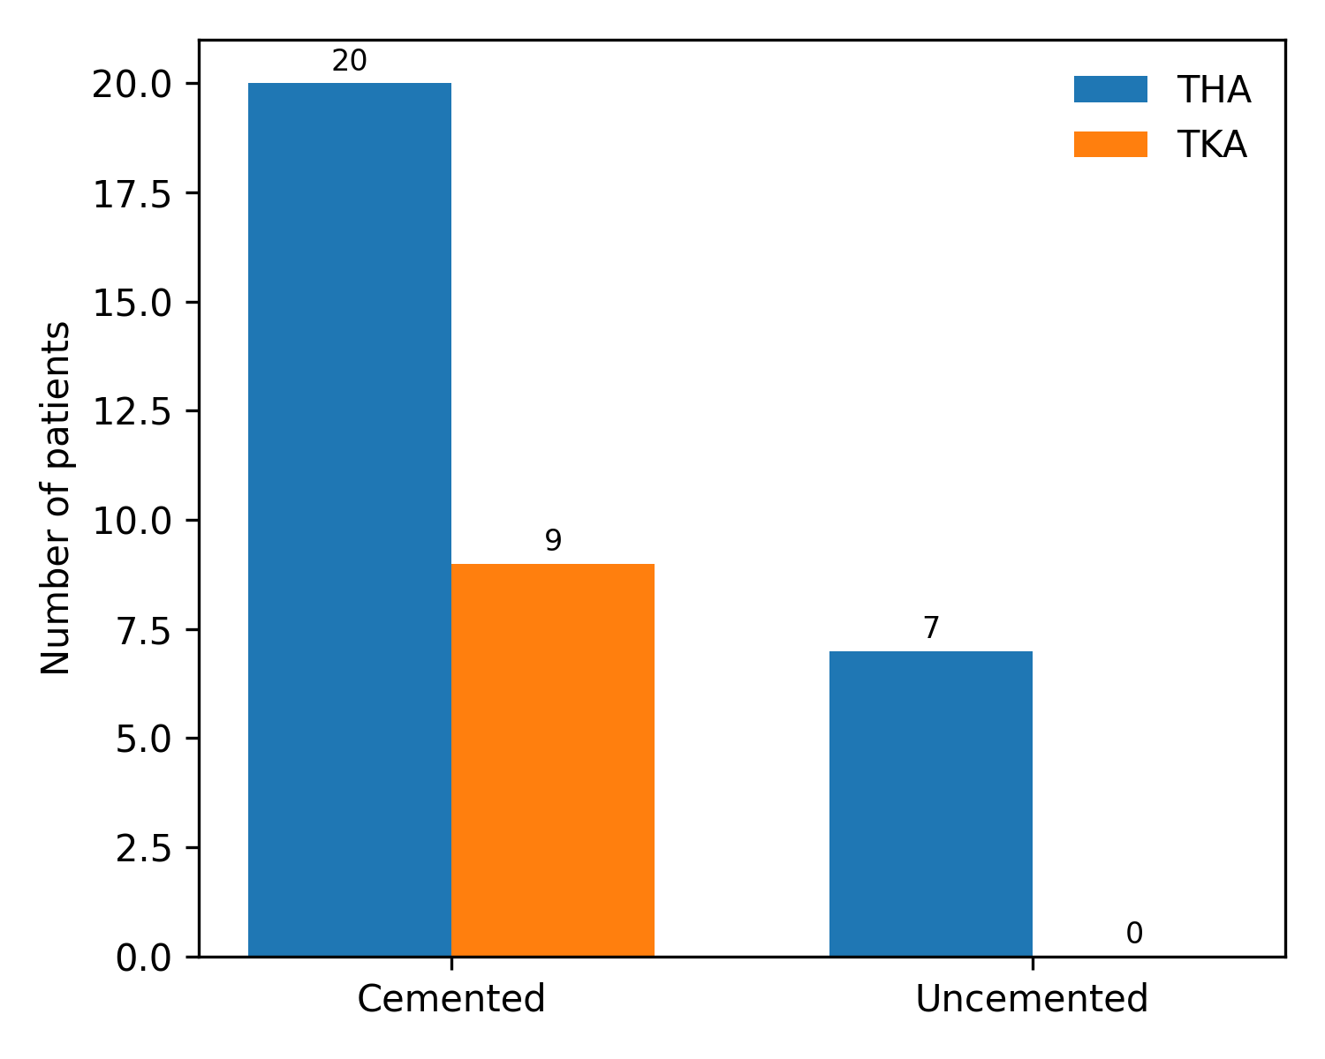
*These results quantify cemented and uncemented procedures only among studies that reported fixation method.
Table 3. Composition of outcomes of revision Total Hip Arthroplasty procedures in patients with Osteogenesis Imperfecta.
Source | Time of Revision (since first THA) | Procedure | Follow-Up Time (since first revision) | Objective Outcomes | Pain / Ambulation
Pascal Bizot | 4 years | Right femoral osteotomy correcting the femur bowing | 1 year | Full bone union obtained | Pain free on both sides; able to walk without any support
Daniel A Charen | 2 years | Revision THA using an extended posterior approach | 6 months | Subsidence of the femoral stem through the lateral femoral condyle | Left knee pain
Daniel A Charen | 2 years, 10 months | Resection of distal tip of implant | 10 months | Further collapse of the osteotomy sites and protrusion of the distal tip of the implant intraarticularly
Daniel A Charen | 3 years, 10 months | Removal of femoral implants, revision THA | 1 year, 10 months | Loosening of the greater trochanter plate, fracture of the cerclage wires, and protrusion of the femoral stem into the knee joint | Persistent lateral knee pain and limited range of motion
Daniel A Charen |  |  | 3 years, 10 months | No femur implant subsidence | No knee pain
Harry Krishnan | 5 years | Revision THA | 10.56 years | Not reported | Not reported
P J Papagelopoulos | 6 years | Resection arthroplasty | 6 months | Degrees of flexion: 100 to 90; Abduction: 40 to 40; Adduction: 20 to 20; External rotation: 30 to 45; Internal rotation: 30 to 45 | Ambulates with wheelchair
R. Ramaswamy | 3 years | Revision THA | 10 years | No evidence of adverse features | Minimal discomfort
* Daniel A Charen describes the revision procedures performed for one patient.

Table 4. Total Hip Arthroplasty Studies: Cemented versus Uncemented Procedures.
Source | Cemented (n) | Uncemented (n) | Additional Notes
Jihad M. Ajlouni | 1 | 0
Pascal Bizot | 0 | 1
Samuel W. Carlson | 9 | 2 | *If the femoral component was cemented, we included it as a cemented procedure in this review. 6 of these procedures involved a hybrid approach with a cemented femoral component and an uncemented acetabular component.
Daniel A Charen | 1 | 0
George W. Chaus | Not reported | Not reported
Harry Krishnan | 2 | 4
Frank A. Liporace | 1 | 0
Kevin Nishida | 1 | 0
P J Papagelopoulos | 4 | 0
Cathleen L. Raggio | Not reported | Not reported
R. Ramaswamy | 1 | 0 | *The patient had a pre-existing uncemented right total hip replacement, but this study focused on the new left hip replacement which involved a hybrid approach involving a cemented femoral component and an uncemented acetabular component.

Table 5. Total Hip Arthroplasty Procedures and Reasons for Surgery.
Source | Reason for Surgery
Jihad M. Ajlouni | Pain and limited hip range of motion due to protrusio acetabuli
Pascal Bizot | Femur non-union, located under an uncemented THA
Samuel W. Carlson | Primary osteoarthritis (7), post traumatic arthritis (2), protrusio, osteonecrosis of the femoral head (1), hip pain status-post hip fusion (1)
Daniel A Charen | Tension-sided femoral neck stress fracture in the setting of coxa vara due to previous Ilizarov lengthening
George W. Chaus | Complete loss of cartilage in the hip joint, and abnormal contour of the femoral head
Harry Krishnan | 4 acetabulum or femoral fractures
Frank A. Liporace | Right-sided scapular body fracture, a rib fracture, and an acetabular fracture
Kevin Nishida | Nonunion of a right femoral neck fracture
P J Papagelopoulos | Osteoarthrosis of hip (1), severe deformities of the proximal part of the femur with subsequent post-traumatic arthritis of the hip (3), acetabulum fracture (1), non-union of a fracture of the femoral neck (1), non-union of a subtrochanteric fracture (1)
Cathleen L. Raggio | Not reported
R. Ramaswamy | Severe osteoarthritis of the hips with exuberant formation of callus in both femora

TKA Outcomes
Tables 6 & 7 summarize outcomes of TKA in patients with OI. Across included studies, the mean sample size was 3 patients per study, with an average age of 52.7 years [17, 18, 24, 26, 29, 31, 34, 40, 41]. Females comprised 52.8% of patients undergoing TKA, while males accounted for 47.2%. The mean follow-up duration across studies was 1.60 years. Detailed study-specific values are presented in Table 6.
Brand et al. reported a patient with complete resolution of left knee pain at 6 weeks postoperatively who did not require revision surgery. Chan et al. similarly reported no pain at 6-week follow-up, with sustained symptom resolution and no revision at 12 months. Kim et al. described outcomes for two patients with osteogenesis imperfecta: in a 58-year-old female, the Knee Society Score improved from 16 to 90 and the functional score from 45 to 100; in a 63-year-old male, the Knee Society Score improved from 18 to 68 and the functional score from 50 to 100. Nishimura et al. reported improvement in Knee Society Score from 20 to 71 and functional score from 40 to 80, with the patient achieving independent ambulation at 1-year follow-up and no need for revision surgery. Papagelopoulos et al. described two patients whose mean Knee Society Score improved from 42 to 83 and mean functional score from 48 to 91; postoperative outcomes were assessed at a mean follow-up of 10 years, though individual patient data were not available.
From the studies included in Table 6, two mentioned revision surgeries for patients. ^{[29, 41]} Data extracted from these studies are depicted in Table 7. The average number of revision surgeries needed per patient was 1. Among studies reporting fixation method, 7 patients underwent cemented total knee arthroplasty, while no patients received uncemented total knee arthroplasty (Figure 2 and Table 8). Table 9 summarizes the indications for total knee arthroplasty across the included studies.
Table 6. Composition of outcomes of Total Knee Arthroplasty procedures in patients with Osteogenesis Imperfecta.
Source | Risk of Bias | Sample Size | Mean Age (years) | Female (n) | Male (n) | Follow-Up Time | Objective Outcomes | Pain / Ambulation | Revision Surgery?
Jordan Brand | NA | 1 | 69 | 1 | 0 | 6 weeks | Degrees of flexion: 0 to 130 | Complete resolution of left knee pain; ambulating independently | No
Ping-Keung Chan | NA | 1 | 44 | 0 | 1 | 6 weeks / 12 months | Oxford Knee Score: 9/48 to 42/48; 42/48 to 45/48 | Significant resolution of pain | No
Raymond H. Kim | Good | 8 | 60.5* | 1 | 1 | 3.5 years* | Knee Society Score: Female 16 to 90; Male 18 to 68 Average function scores: Female 45 to 100; Male 50 to 100 | Significant resolution of pain | No
Akinobu Nishimura | NA | 1 | 53 | 0 | 1 | 1 year | Knee Society score: 20 to 71 Knee Society function score: 40 to 80 | Independent ambulation | No
Timo K. Nuutinen | Good | 9 | 61 | 7 | 2 | 3 years | Oxford Knee Score: 40/48** (no pre-op measurement) Range of motion: 103 pre-op to 113 post-op | Pain in the right knee and signs of aseptic loosening around the femur component | Yes
P J Papagelopoulos | Good | 6 | 50 | 2 | 0 | 10 years | Knee Society Score: 42 to 83* Average function score: 48 to 91* | Partial relief of pain, improvement in ability to walk | No
Allan Roy Sekeitto | NA | 1 | 52 | 1 | 0 | 6 months / 2 years | WOMAC Knee Score: 36.4 to 59.4; 36.4 to 86.4 | VAS: 7/10 at 6 months; VAS: 2/10 at 2 years | No
Pavel Sponer | NA | 1 | 62 | 1 | 0 | 6 weeks | Hospital for Special Surgery knee score: 52.5 to 85.25 | No pain, ambulated with the help of elbow crutches | No
Russell Wagner | NA | 1 | 46 | 0 | 1 | 11.5 months | Right tibial non union | Not reported | Yes
Russell Wagner | NA | 1 | 37 | 0 | 1 | 6 months / 9 months | No evidence of complications of right knee; Radiolucent gap at the proximal tibial osteotomy site (left knee) | Pain free, ambulating independently; Mild discomfort | Yes
NA: Case study - Risk of Bias assessment not conducted.
* Each patient in the study was described to have a distinct value. This table presents the average.
** Patient had TKA on both knees; score is an average of both knees (Right: 39/48, Left: 42/48).
*** WOMAC: Western Ontario and McMaster Universities Osteoarthritis Index.

Table 7. Composition of outcomes of revision Total Knee Arthroplasty procedures in patients with Osteogenesis Imperfecta.
Source | Time of Revision (since first TKA) | Procedure | Follow-Up Time (since first revision) | Objective Outcomes | Pain / Ambulation
Timo K. Nuutinen | 3 years | Femoral component exchanged | 5 years | Evidence of aseptic loosening | Not reported
Russell Wagner | 11.5 months | Open reduction internal fixation (ORIF) with iliac crest bone graft | 3.5 months | Not reported | No pain, ambulating independently
Russell Wagner | 9 months | Revision TKA | 2 years | Not reported | No pain, ambulating independently

Table 8. Total Knee Arthroplasty Studies: Cemented versus Uncemented Procedures.
Source | Cemented (n) | Uncemented (n)
Jordan Brand | Not reported | Not reported
Ping-Keung Chan | 1 | 0
Raymond H. Kim | 1 | Not reported
Akinobu Nishimura | 1 | 0
Timo K. Nuutinen | Not reported | Not reported
P J Papagelopoulos | 2 | 0
Allan Roy Sekeitto | 1 | 0
Pavel Sponer | 1 | 0
Russell Wagner | 1 | 0
Russell Wagner | 1 | 0

Table 9. Total Knee Arthroplasty and Reasons for Surgery.
Source | Reason for Surgery
Jordan Brand | Bone-on-bone degenerative changes of the lateral compartment with severe genu valgum
Ping-Keung Chan | Kellgren-Lawrence Grade IV tricompartmental osteoarthritis of the right knee
Raymond H. Kim | Not reported
Akinobu Nishimura | Osteoarthritis of the bilateral knee from repeated malaligned fractures
Timo K. Nuutinen | Not reported
P J Papagelopoulos | Osteoarthrosis of knee (2)
Allan Roy Sekeitto | Fall rupturing her anterior cruciate ligament (ACL); past medical history: degenerative changes in her right knee with a deficient medial collateral ligament (MCL) of clinical grade 3
Pavel Sponer | Genu valgum deformity with osteoarthritis
Russell Wagner | Intramedullary retrograde Rush rod and a malunion of the right distal femur with a 27° varus deformity and "bone-on-bone" medial compartment arthritis
Russell Wagner | Anterolateral bowing of the tibia with varus alignment of the knee and anterior subluxation of the tibia

Discussion
Patients with OI who undergo THA or TKA can experience meaningful improvements in pain and functionality but face high rates of revision surgery and unique technical challenges [16, 23, 36]. This systematic review found reported revision proportions in included cases of 29% following THA and 44% following TKA due to loosening or malunion. The low rates of independent ambulation and pain-free status reflect the underlying severity of OI and the technical limitations of surgery in this group. The mean age of patients with osteogenesis imperfecta undergoing THA in this review was substantially younger (41.73 years) than that reported for patients without OI undergoing THA in the literature (69.4 years) [42]. Consistent with the findings for THA, the mean age of patients with OI undergoing TKA in this review was 52.7 years, markedly younger than the mean age of 70.1 years reported for patients without OI undergoing TKA [42].
For THA in patients with OI, studies report significant functional improvement and pain relief, but long-term implant survivorship is low and revision rates are high [16, 23, 25, 26, 36]. Carlson et al. found a 31% revision rate at a mean of 13 years, with survivorship free of revision at 52% at 20 years; however, Harris Hip Scores improved significantly postoperatively, indicating functional benefit [16]. These complications are primarily due to bone fragility, deformity, and poor bone quality unique to OI. Roberts et al. and Bizot further emphasize that OI patients face unique surgical challenges, including high rates of malunion, nonunion, and intraoperative complexity [23, 36]. These outcomes are less favorable than those seen in the general population, but THA remains an option for pain relief and improved mobility in OI [25].
To contextualize these findings, reported 10-year revision rates for total hip arthroplasty in patients without osteogenesis imperfecta are approximately 4–5% [43-45]. This is substantially lower than the 29% revision rate observed in the present review. Notably, many revision procedures in the included studies occurred within 2–6 years of the index arthroplasty, well before the conventional 10-year benchmark used for outcome comparison.
For TKA in patients with OI, the literature is sparse. However, the results appear similar to the outcomes of THA: pain relief and functional improvement are achievable, yet revision rates remain high. Sponer et al. and Nishimura et al. describe technical challenges due to bone deformity and fragility, but report substantial improvement in knee scores and ambulation postoperatively [17, 18]. Kim et al. highlights the need for customized implants and careful soft tissue balancing, with short-term improvements in pain and function, but complications such as nerve palsy and periprosthetic fracture are not uncommon [26].
To place these findings in the broader context of total knee arthroplasty in patients without osteogenesis imperfecta, 10-year revision rates are typically reported at approximately 3–5% [46, 47]. This is markedly lower than the 44% revision rate observed in the present review. Moreover, many revision procedures occurred within 9 months to 2 years following the index arthroplasty, substantially earlier than the conventional 10-year benchmark.
This review identified a higher proportion of cemented compared with uncemented fixation for both total hip and total knee arthroplasty. The preference for cemented fixation in patients with osteogenesis imperfecta parallels established recommendations for arthroplasty in osteoporotic bone. Poor bone quality in OI limits the ability to achieve reliable press-fit fixation, thereby increasing the risk of periprosthetic fracture and early loosening [48]. Forlino et al. further suggest that custom implants designed using computer-assisted techniques may yield superior outcomes for hip and knee arthroplasty in adults with OI [1]. Notably, the existing evidence base is largely composed of case reports and expert opinion.
The limited published data and predominance of case reports on total hip and knee arthroplasty in patients with OI significantly constrain our understanding of long-term outcomes, optimal follow-up, and revision risk compared to the robust literature available for the general population. Most studies in OI are small case series or single case reports, with the largest sample size at 11 patients. Additionally, follow-up durations that rarely exceed a decade, so long term outcomes and revision risks in OI remain uncertain [16-18, 25]. While available reports suggest higher revision rates and unique technical challenges due to bone fragility and deformity, the true incidence and timing of complications may vary due to the small, heterogenous sample sizes. Registry data in young adults and pediatric populations, which include some OI cases, show lower revision rates at five years. However, these cohorts include other skeletal dysplasia and are not disease specific [49, 50]. Future research should focus on leveraging large national and international databases to better characterize long-term outcomes of total hip and knee arthroplasty in patients with osteogenesis imperfecta.
This systematic review is also limited by the substantial lack of standardization in outcome reporting across the included studies. Among studies evaluating THA in patients with OI, objective outcomes were measured differently across the studies across different follow up time points, making direct comparisons across studies difficult. For example, the THA studies mentioned use Harris Hip Scores, Oxford Hip Scores, isolated radiographic findings, or a combination of these measures. Similarly, in TKA studies, outcome reporting was heterogeneous, with some studies utilizing Oxford Knee Scores, Knee Society Scores, or WOMAC scores, while others reported only radiologic outcomes. In addition, patient-reported outcomes regarding pain and ambulatory capacity were inconsistently documented and not reported in every study. Furthermore, much of the data regarding functional improvements or pain were reported at different follow up intervals in every study. Much of this heterogeneity can be attributed to the predominance of case reports among the included studies. These limitations underscore the need for future studies with standardized outcome measures and consistent reporting to allow for more robust comparative analysis.
Conclusion
Although total hip and knee arthroplasty can provide symptomatic and functional benefit for patients with osteogenesis imperfecta, patients often require revision procedures due to malunion or bone loosening. Only a minority of patients who underwent THA reported complete pain relief and independent ambulation following surgery, while a substantial proportion required revision procedures, most commonly due to loosening or bone malunion. In contrast, a larger proportion of patients who underwent TKA reported complete pain relief, although independent ambulation remained uncommon, and revision surgery due to loosening or bone malunion was frequently reported. The existing literature on this topic is limited, with even fewer studies specifically addressing TKA in patients with osteogenesis imperfecta.

References

1. Forlino, A. and J.C. Marini, Osteogenesis imperfecta. Lancet, 2016. 387(10028): p. 1657-71.
2. Marom, R., B.M. Rabenhorst, and R. Morello, Osteogenesis imperfecta: an update on clinical features and therapies. Eur J Endocrinol, 2020. 183(4): p. R95-R106.
3. Etich, J., et al., Signaling pathways affected by mutations causing osteogenesis imperfecta. Cell Signal, 2020. 76: p. 109789.
4. Jovanovic, M. and J.C. Marini, Update on the Genetics of Osteogenesis Imperfecta. Calcif Tissue Int, 2024. 115(6): p. 891-914.
5. Lim, J., et al., Genetic causes and mechanisms of Osteogenesis Imperfecta. Bone, 2017. 102: p. 40-49.
6. Tournis, S. and A.D. Dede, Osteogenesis imperfecta - A clinical update. Metabolism, 2018. 80: p. 27-37.
7. van Welzenis, T., et al., The IMPACT Survey: the humanistic impact of osteogenesis imperfecta in adults. BMC Public Health, 2024. 24(1): p. 3318.
8. Wehrli, S., M. Rohrbach, and M.A. Landolt, Quality of life of pediatric and adult individuals with osteogenesis imperfecta: a meta-analysis. Orphanet J Rare Dis, 2023. 18(1): p. 123.
9. Westerheim, I., et al., The IMPACT survey: a mixed methods study to understand the experience of children, adolescents and adults with osteogenesis imperfecta and their caregivers. Orphanet J Rare Dis, 2024. 19(1): p. 128.
10. Mc Donald, D., et al., Systematic review of health related-quality of life in adults with osteogenesis imperfecta. Orphanet J Rare Dis, 2023. 18(1): p. 36.
11. Derocher, C.E., et al., Health-related quality of life in individuals with osteogenesis imperfecta in the United States: a cross-sectional study. Orphanet J Rare Dis, 2025. 20(1): p. 537.
12. Dahan-Oliel, N., et al., Quality of life in osteogenesis imperfecta: A mixed-methods systematic review. Am J Med Genet A, 2016. 170A(1): p. 62-76.
13. Hald, J.D., et al., Health-Related Quality of Life in Adults with Osteogenesis Imperfecta. Calcif Tissue Int, 2017. 101(5): p. 473-478.
14. Munoz Cortes, R., J.F. Soriano Pastor, and V. Monsalve Dolz, Chronic pain in adults with osteogenesis imperfecta and its relationship to appraisal, coping, and quality of life: A cross-sectional study. Medicine (Baltimore), 2022. 101(40): p. e30256.
15. Matsushita, M., et al., Impact of fracture characteristics and disease-specific complications on health-related quality of life in osteogenesis imperfecta. J Bone Miner Metab, 2020. 38(1): p. 109-116.
16. Carlson, S.W., R.J. Sierra, and R.T. Trousdale, Total Hip Arthroplasty in Patients With Osteogenesis Imperfecta. J Arthroplasty, 2020. 35(8): p. 2131-2135.
17. Sponer, P., M. Korbel, and T. Kucera, Challenges of total knee arthroplasty in osteogenesis imperfecta: case report and literature review. J Int Med Res, 2022. 50(5): p. 3000605221097369.
18. Nishimura, A., et al., Total knee arthroplasty in osteogenesis imperfecta: case report. Knee, 2008. 15(6): p. 494-6.
19. Andersen, J.D., et al., Osteoarthritis in osteogenesis imperfecta: A nationwide register-based cohort study. Bone, 2022. 154: p. 116222.
20. Ralston, S.H. and M.S. Gaston, Management of Osteogenesis Imperfecta. Front Endocrinol (Lausanne), 2019. 10: p. 924.
21. Rodriguez Celin M, S.R., Basel D, COL1A1- and COL1A2-Related Osteogenesis Imperfecta. GeneReviews, 2005, [Updated 2025 May 29].
22. Ajlouni, J.M., U.N. Isleem, and A.E. Al Elaumi, Total hip arthroplasty for Protrusio Acetabuli in a young adult Osteogenesis Imperfecta features and Marfanoid features: A case report. J Clin Orthop Trauma, 2020. 11(1): p. 96-98.
23. Bizot, P., Orthopedic Surgery in Osteogenesis Imperfecta in Adults. CALCIFIED TISSUE INTERNATIONAL, 2024. 115(6): p. 976-988.
24. Brand, J., V. Tyagi, and L. Rubin, Total knee arthroplasty in osteogenesis imperfecta. Arthroplast Today, 2019. 5(2): p. 176-180.
25. Chaus, G.W. and T. Heare, End-stage posttraumatic osteoarthritis treated with THA in osteogenesis imperfecta. Orthopedics, 2012. 35(6): p. e950-3.
26. Kim, R.H., et al., Technical challenges of total knee arthroplasty in skeletal dysplasia. Clin Orthop Relat Res, 2011. 469(1): p. 69-75.
27. Krishnan, H., et al., Primary and revision total hip arthroplasty in osteogenesis imperfecta. Hip Int, 2013. 23(3): p. 303-9.
28. Liporace, F.A., et al., Single-stage total hip arthroplasty and fracture fixation for a both column acetabular fracture in type I osteogenesis imperfecta. Injury, 2011. 42(10): p. 1184-7.
29. Nuutinen, T.K., et al., Custom-made hinged total knee arthroplasties in the context of extra-articular deformity: a case series. European Journal of Orthopaedic Surgery and Traumatology, 2023. 33(4): p. 1411EP-1420.
30. Osagie, L., M. Figgie, and M. Bostrom, Custom total hip arthroplasty in skeletal dysplasia. Int Orthop, 2012. 36(3): p. 527-31.
31. Papagelopoulos, P.J. and B.F. Morrey, Hip and knee replacement in osteogenesis imperfecta. J Bone Joint Surg Am, 1993. 75(4): p. 572-80.
32. Raggio, C.L., et al., Joint Replacements in Individuals With Skeletal Dysplasias: One Institution's Experience and Response to Operative Complications. Journal of Arthroplasty, 2020. 35(8): p. 1993EP-2001.
33. Ramaswamy, R., Y. Kosashvili, and H. Cameron, Bilateral total hip replacement in osteogenesis imperfecta with hyperplastic callus. J Bone Joint Surg Br, 2009. 91(6): p. 812-4.
34. Sekeitto, A.R., et al., Total knee replacement in Osteogenesis Imperfecta: a case report and review of the literature. Arthroplasty, 2021. 3(1): p. 4.
35. Sepehri, A., A. Sidhu, and B.A. Masri, Total Hip Replacements in Patients with Rare Pathologic Conditions Affecting Bone. J Bone Joint Surg Am, 2021. 103(14): p. 1355-1362.
36. Roberts, T.T., et al., Orthopaedic Considerations for the Adult With Osteogenesis Imperfecta. J Am Acad Orthop Surg, 2016. 24(5): p. 298-308.
37. Ain, M.C., et al., Total hip arthroplasty in skeletal dysplasias: patient selection, preoperative planning, and operative techniques. J Arthroplasty, 2004. 19(1): p. 1-7.
38. Charen, D.A., S. Selverian, and E. Adler, Addition of a Distal Femur Locking Plate to Augment Total Hip Arthroplasty in Osteogenesis Imperfecta: A Case Report. JBJS Case Connect, 2021. 11(3).
39. Nishida, K., D. Choi, and M. Bostrom, Custom hemiarthroplasties for retention of existing hardware associated with osteogenesis imperfecta. Arthroplasty Today, 2017. 3(2): p. 89EP-92.
40. Chan, P.K., et al., Three-Dimensional Printing and Computer Navigation for Correction of Multiple Deformities in Osteogenesis Imperfecta: A Case Report. JBJS Case Connect, 2021. 11(2).
41. Wagner, R. and C. Luedke, Total knee arthroplasty with concurrent femoral and tibial osteotomies in osteogenesis imperfecta. Am J Orthop (Belle Mead NJ), 2014. 43(1): p. 37-42.
42. Bayliss, L.E., et al., The effect of patient age at intervention on risk of implant revision after total replacement of the hip or knee: a population-based cohort study. Lancet, 2017. 389(10077): p. 1424-1430.
43. Kandala, N.B., et al., Setting benchmark revision rates for total hip replacement: analysis of registry evidence. BMJ, 2015. 350: p. h756.
44. Deere, K., et al., How long do revised and multiply revised hip replacements last? A retrospective observational study of the National Joint Registry. Lancet Rheumatol, 2022. 4(7): p. e468-e479.
45. Jones, C.M., et al., Trends and Epidemiology in Revision Total Hip Arthroplasty: A Large Database Study. J Arthroplasty, 2025. 40(8S1): p. S255-S261 e1.
46. Stone, B., et al., The lifetime risk of revision following total knee arthroplasty : a New Zealand Joint Registry study. Bone Joint J, 2022. 104-B(2): p. 235-241.
47. Price, A.J., et al., Knee replacement. Lancet, 2018. 392(10158): p. 1672-1682.
48. Walsh, C.P., et al., Total Knee Arthroplasty in the Osteoporotic Tibia: A Biomechanical Evaluation of the Role of Stem Extensions and Cementing Techniques. J Am Acad Orthop Surg, 2019. 27(10): p. 370-374.
49. Sedrakyan, A., et al., Survivorship of hip and knee implants in pediatric and young adult populations: analysis of registry and published data. J Bone Joint Surg Am, 2014. 96 Suppl 1(Suppl 1): p. 73-8.
50. Halvorsen, V., et al., Outcome of 881 total hip arthroplasties in 747 patients 21 years or younger: data from the Nordic Arthroplasty Register Association (NARA) 1995-2016. Acta Orthop, 2019. 90(4): p. 331-337.

